The distortion of small spheres is not due to a loss of precision in floating point numbers. This can be easily seen since floats have up to 17 decimal places of accuracy, and a sphere of size 0.001 will use around only 5 digits.

Instead, the problem is with the way RC scales its objects. The model for a sphere is slightly disproportioned, with the length and height being 0.001 units larger than the width. However, this is not an error in the model since this number would get larger and smaller with the object size.

This makes fixing the problem very easy. No matter what size the sphere is, simply add 0.001 to the width and the problem will be solved

Table Below

L = 1 W = 1 H = 1 | L = 1 W = 1.001 H = 1
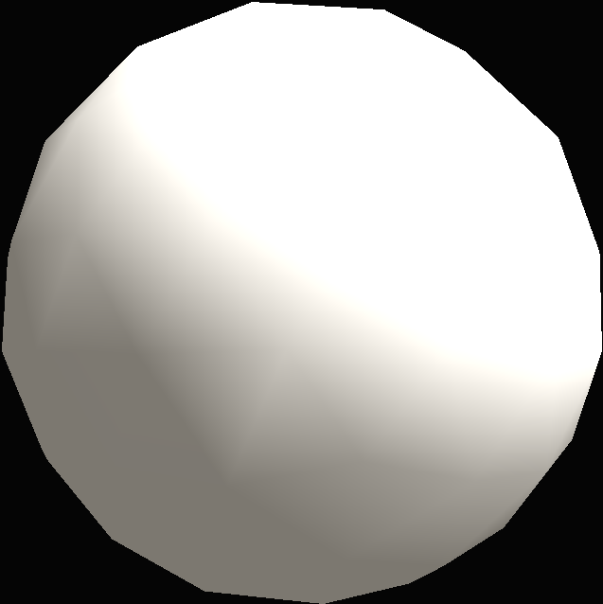 | 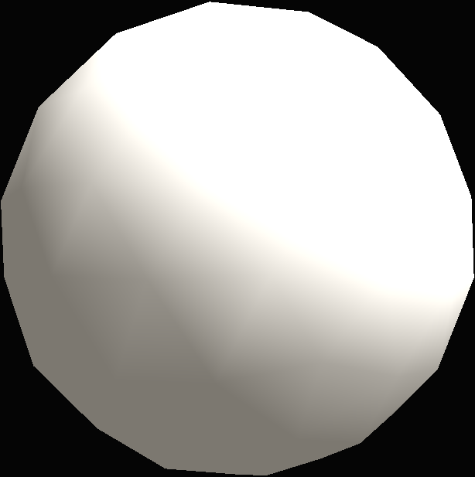

L = 0.5 W = 0.5 H = 0.5 | L = 0.5 W = 0.5001 H = 0.5
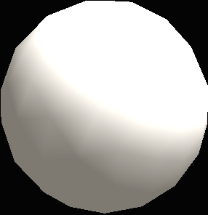 | 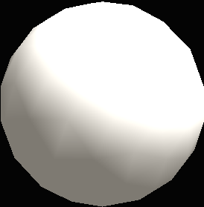

L = 0.01 W = 0.01 H = 0.01 | L = 0.01 W = 0.011 H = 0.01
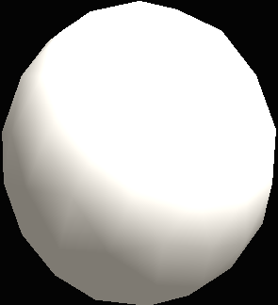 | 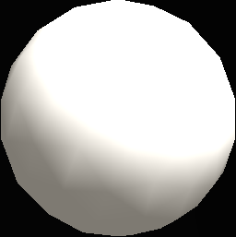

L = 0.005 W = 0.005 H = 0.005 | L = 0.005 W = 0.006 H = 0.005
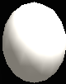 | 

L = 0.002 W = 0.002 H = 0.002 | L = 0.002 W = 0.003 H = 0.002
 | 

L = 0.0015 W = 0.0015 H = 0.0015 | L = 0.0015 W = 0.0025 H = 0.0015
 | 

L = 0.001 W = 0.002 H = 0.001 | L = 0.001 W = 0.002 H = 0.001


L = 0.0001 W = 0.0001 H = 0.0001 | L = 0.0001 W = 0.0002 H = 0.0001


